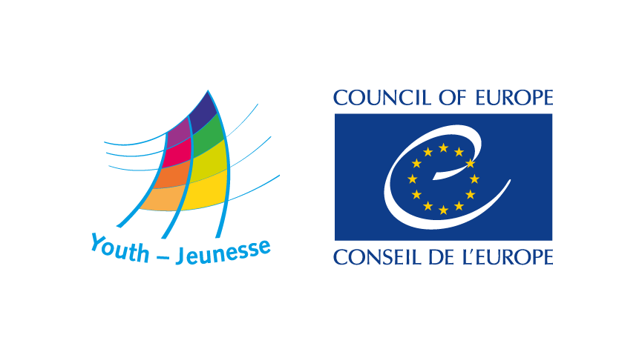


DDP-YD/ETD (2019) 17 Strasbourg, 7 March 2019

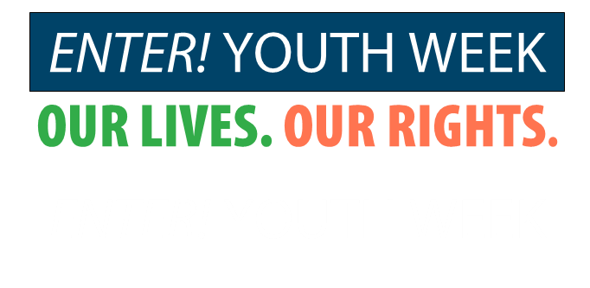

Young people share their experiences in accessing social rights and celebrate the impact of the
Council of Europe on their everyday life

European Youth Centre, Strasbourg, France 7-12 July 2019

Call for Participants

Enter! = Solidarity, No to Discrimination
For the Council of Europe, social cohesion is firmly based on human rights as codified in the European Convention on Human Rights and the Revised European Social Charter, as well as an acceptance of shared responsibility for the welfare of all members of society, especially those who are at risk of poverty or exclusion.
In line with this, the youth policy of the Council of Europe aims at providing young people with equal opportunities and experience which enable them to develop knowledge, skills and competencies to play a full part in all aspects of society.

The Council of Europe launched the Enter! project to identify and promote responses to violence, exclusion and discrimination affecting young people in Europe, notably in disadvantaged neighbourhoods. In 2015, the Committee of Ministers of the Council of Europe adopted Recommendation CMRec(2015)3 (the Enter! Recommendation) on access of young people from disadvantaged neighbourhoods to social rights. The recommendation calls on member states to implement sustainable, evidence-based public policies that take into consideration the specific situations and needs of young people from disadvantaged neighbourhoods. These policies aim at preventing and eradicating the poverty, discrimination, violence and exclusion often faced by such young people.

The Enter! Youth Week

In 2019 the Joint Council on Youth is reviewing how the recommendation is being applied in youth policy and youth work across the member states and what impact it has on young people from disadvantaged neighourhoods. The review includes a meeting with young people so that they can directly discuss the findings and recommendations from the review process. This is the key purpose of the Enter! Youth Week.

The Enter! Youth Week will associate young people and youth workers to review the process of the implementation of the recommendation by the member states and other partners. Organised at the occasion of the 70th anniversary of the Council of Europe, in the framework of the Chairmanship of France of the Committee of Ministers, the week should also be an example of young people’s participation in the Council of Europe’s mission and work. Youth workers and young people will share experiences concerning access to social rights from a local point of view. These experiences will then be taken into account at national and European level so as to improve the outcomes and findings of the Enter! Recommendation review process. The week will unite young people with the shared aim of building a Europe based on human rights, democracy and inclusion. It will be a forum for youth engagement and exchanges between participants from all member states, celebrating their diversity and their creativity.

The week will bring together some 200 young people and 50 youth workers, along with representatives of youth organisations promoting access of young people to their rights.

Objectives of the week

To contribute to the review of the implementation of the Enter! Recommendation with inputs from young people and youth workers based on their life realities and their expectations regarding access to social rights

To discuss and highlight the role of youth work and local youth policies in promoting young people’s access to social rights

To celebrate the 70th anniversary of the Council of Europe, highlighting young people’s commitment and contributions to human rights and democracy, in the framework of the priorities of the French chairmanship of the Council of Europe

To develop proposals for short and long-term action to advance young people’s access to social rights by the Council of Europe and by national and local authorities

To provide an intercultural learning experience based on creativity and interaction with young people in the city of Strasbourg.

Outputs

The work of the participants during the week will be put together and published in four ways:

Conclusions and proposals regarding the review of the Enter! recommendation and the realities of access to social for young people from disadvantaged neighbourhoods

A Message to the Council of Europe at the occasion of the 70th anniversary containing the participants expectations and wishes

A film/video report of the week

A written report/publication with the highlights of the week.

Participants

The Enter! Youth Week will bring together some 200 young people and 50 youth workers and representatives of local authorities, along with representatives of youth organisations promoting access of young people to their rights.

The participants should apply in groups (national, local, neighbourhood group) and each group should be accompanied by a youth worker. Ideally, the youth worker and the young people within the group should already have been involved in activities about young people’s access to rights. Individual applications will also be taken into account in limited numbers.

All participants (young people youth workers, representatives of local authorities) should be active or coming from projects or environments linked with the Enter! Recommendation. These are, for example:

Projects devised and implemented by participants of the Enter! Long term training courses

Projects on access to social rights for young people from disadvantaged neighbourhoods funded by the European Youth Foundation

Youth work projects or programmes supported by the national or local authorities which are taking place in a disadvantaged neighbourhood and have an aim to improve access to social rights for young people

Projects implemented by local or regional authorities in the framework of support measures under the Enter! project or of the Congress of Local and Regional Authorities

Youth work projects or activities of youth organisations running study sessions in cooperation with the European Youth Centres

Youth centres that have been awarded the Council of Europe Quality Label

Partner organisations and participants from activities implemented in the framework of Council of Europe Action Plans (such as Azerbaijan, Belarus, Russian Federation, Ukraine).

Organisations, networks or groups interested in participating in the week must apply with a group. Each group should be composed of at least 2 and maximum 10 young people, accompanied by youth workers. Each group should be gender balanced.

All participants should:

come from a member state of the Council of Europe or state signatory of the European Cultural Convention

be between 16 to 23 years of age (young people under 18 will need to have specific procedures and authorisations in place)

be able to work in English or French, the two working languages of the week

be involved in a youth work project on access to social rights

be able to share their experiences and ideas and be motivated to take full part in the Enter! Youth Week.

The Council of Europe welcomes applications from all young people and youth workers who fulfil the specific criteria of this call irrespective of gender, disability, marital or parental status, racial, ethnic or social origin, religion, belief or sexual orientation.

Application procedure and selection of participants

When applying, the organisation youth worker responsible to accompany the group of young participants should secure that they will be available, interested and prepared to participate in the Enter! Youth Week. When applying, a provisional list of participants must be submitted. This list may be slightly adjusted after the selection procedure.

All applications must be completed online at http://youthapplications.coe.int/ by 17 May 2019.

Practical and financial conditions

Travel costs
The sending partners or organisations are requested to fundraise to cover for the travel expenses of their participants to Strasbourg and return.
In exceptional circumstances the Council of Europe may be able to cover for some travel expenses when this is justified and fits with the budgetary limits of the activity.

Visa costs
Visa costs will be reimbursed by the Council of Europe upon presentation of the necessary evidence and documents. The Council of Europe will also issue invitation letters for visa purposes when needed.

Venue and accommodation
The Enter! Youth Week will be held in Strasbourg, France, at the European Youth Centre and in the headquarters of the Council of Europe.
The Council of Europe will provide meals for all participants and accommodation at the European Youth Centre or in nearby hotels for the duration of the week’s programme.

Working languages
The course will be held in English and French. Simultaneous interpretation will be provided for plenary sessions and a limited number of working groups.

Further information and contact
For further information or queries related to this call, please contact youth_enter@coe.int

